Department of Computer Science and Engineering
2025-2026
Odd Semester


DATA STRUCTURES AND ALGORITHMS-3
(25CS2103E)

CargoRoute — Multimodal Freight & Fleet Optimization Platform

Yalamanchili Yashwanth 2520030506
Sanjana Kanaparthi 2520030229
Gajengi Keerthi 2520030092

COURSE INSTRUCTOR

Dr. Swathi
Professor
Department of Computer Science and Engineering
CARGOROUTE — MULTIMODAL FREIGHT & FLEET OPTIMIZATION PLATFORM
1. Introduction and Case Study Background
Freight movement in India is a large and cost-sensitive activity. A logistics company must decide, for every consignment, which route and which mode of transport (road, rail or air) to use, and must keep its trucks as full as possible, because every kilometre driven with empty space is lost income. In practice these decisions are made by phone calls and spreadsheets, which is slow and often leaves capacity unused.
CargoRoute is a web-based Transport Management System (TMS) built as a Smart India Hackathon 2026 prototype to solve this. It gives an operations team one dashboard from which they can (a) plan and compare multimodal routes for a shipment, (b) detect spare space on trucks that are already on the road and fill it with cargo from intermediate hubs, and (c) monitor the fleet, drivers, maintenance, expenses and profit in one place. The application runs entirely in the browser and uses simulated data (“Demo Simulation Mode”), so it can be demonstrated without any backend.
2. Problem Statement
Long-haul trucks on a corridor such as Hyderabad → Nagpur → Bhopal → Delhi often leave with spare weight and volume capacity, while cargo is waiting at the intermediate hubs. At the same time, planners have no quick way to compare a pure-road, pure-rail, rail-plus-road or air option on cost, time, transfers and carbon emissions. The problem is to build a system that ranks the available transport options for a consignment and matches spare truck capacity with intermediate cargo, while never exceeding the truck’s weight or volume limit.
3. Objectives
• Model hubs, vehicles, drivers, shipments, routes and services as typed data structures.
• Generate and rank multimodal route options for an origin–destination pair using weight, distance, cost, time and CO₂.
• Check every proposed load against both the weight and the volume limit of the truck (dual-constraint check).
• Evaluate the profit of picking up cargo at an intermediate stop and update the truck, shipment list and alerts when it is accepted.
• Aggregate fleet KPIs (revenue, operating cost, profit, utilization) and support “what-if” scenario changes.
• Present all results through an interactive dashboard with charts, tables and a live-tracking map.
4. System Overview
The application has a public landing page and a dashboard shell with thirteen pages. All pages share one React Context (LogisticsContext) that holds the data and the actions that change it, so a change made on one page (for example accepting intermediate cargo) is reflected everywhere at once.
Page | Purpose
Executive Dashboard | KPIs, revenue/profit trend, fleet-status chart, top backhaul opportunity banner
Route Optimizer | Compares Rail + Road, Direct Truck, Rail and Air options for a shipment and books the chosen one
Capacity Optimizer | Pairs spare truck headroom with intermediate cargo; weight/volume telemetry; accept action
Shipments | Searchable / filterable shipment register with create-shipment form
Fleet and Vehicle Detail | Vehicle list with status filter; per-vehicle load, route stops, health score
Live Fleet Tracking | Map (Leaflet) with simulated vehicle movement
Drivers, Maintenance, Expenses | Driver performance, service records, categorised expense log
Profitability and Investor | Corridor-wise profit ranking, scenario sliders (diesel price, freight rate, fleet size, utilization)
Reports and About | CSV export / print report and project information

5. Technology Stack
Layer | Technology (from package.json)
Language / UI | TypeScript, React 19.2
Build tool | Vite 8, Oxlint
Styling / animation | Tailwind CSS 4, Framer Motion, lucide-react icons, canvas-confetti
Routing | React Router 7 (client-side routes)
Charts and maps | Recharts (area and pie charts), Leaflet / react-leaflet (tracking map)
State and data | React Context + in-memory TypeScript data modules (no backend or database)

6. Data Model
Every entity is declared as a TypeScript interface in types/index.ts. The simulated data set contains 14 hubs (Hyderabad, Nagpur, Bhopal, Delhi, Mumbai, Pune, Bengaluru, Chennai, Kolkata, Ahmedabad, Jaipur, Varanasi, Surat, Belagavi), 8 vehicles, 6 drivers, 6 shipments, 3 intermediate-cargo opportunities, 6 maintenance records, 8 expense records and 4 alerts.
Entity | Important fields
Vehicle | regNumber, status, maxWeightTons / currentWeightTons, maxVolumeM3 / currentVolumeM3, routeStops[], currentStopIndex, mileage, health score
Shipment | origin, destination, weightTons, volumeM3, priority, transportMode, revenue, allocated fuel/driver/maintenance/toll/handling cost, profit
RouteOption | corridor, totalDistanceKm, totalDurationHours, estimatedCost, suggestedCustomerPrice, expectedProfit, co2Kg, numberOfTransfers, legs[], matchScore
ServiceDetail | one leg of a route: mode (Truck / Train / Flight), service name, timings, cargo capacity, used and available capacity, cost
IntermediateOpportunity | origin, destination, weight, volume, offeredRevenue, target vehicle, additional costs, netAdditionalProfit, recommendation (ACCEPT / REVIEW / REJECT)
ScenarioParameters | dieselPricePerL, freightRatePerKm, driver and maintenance multipliers, fleetUtilizationPct, fleetSize

7. Worked Example 1 — Route Planning (Hyderabad → Delhi)
Input: origin Hyderabad, destination Delhi, cargo 8.5 tonnes, 32 m³, Electronics, mode “Multimodal”. Because the pair is Hyderabad–Delhi the base distance is 1,560 km. The optimizer returns four ranked corridors (values below are produced by the formulas of Algorithm 2 and match the screenshot in the Results section):
Option | Mode | Time | Operating cost | Customer price | Profit | CO₂ (kg) | Match
Best Overall (Rail + Road) | Multimodal | 32 h | ₹45,640 | ₹67,470 | ₹21,830 | 5,569 | 97
Direct Dedicated Truck | Truck | 38 h | ₹51,310 | ₹73,140 | ₹21,830 | 10,343 | 91
Cheapest Rail Freight | Train | 44 h | ₹33,450 | ₹52,870 | ₹19,420 | 2,917 | 89
Fastest Air Express | Flight | 6.5 h | ₹75,750 | ₹1,15,750 | ₹40,000 | 24,531 | 84

The recommended option is truck Hyderabad → Nagpur Hub (502 km, 10 h) followed by train Nagpur → Delhi (1,058 km, 18 h), with one transfer. It is neither the cheapest (rail) nor the fastest (air) but gives the best balance, so it carries the highest match score. The planner can then press “Dispatch & Book Shipment”, which creates a new shipment in the shared state.
8. Worked Example 2 — Filling Spare Truck Capacity
Truck TS09AB1234 (32 FT multi-axle, limit 15.0 T and 60 m³) is travelling Hyderabad → Delhi and is currently at Nagpur carrying 12.3 T and 42.0 m³. A customer offers 2.4 T / 9.6 m³ of electronics from Nagpur to Bhopal for ₹26,000, and Bhopal is the next stop on the truck’s route.
• Weight check: 12.3 + 2.4 = 14.7 T ≤ 15.0 T → fits (98 % utilized, 0.3 T free).
• Volume check: 42.0 + 9.6 = 51.6 m³ ≤ 60.0 m³ → fits (86 % utilized, 8.4 m³ free).
• Additional cost = fuel 2,800 + driver 1,200 + maintenance 800 + toll 1,200 = ₹6,000.
• Net additional profit = 26,000 − 6,000 = ₹20,000; incremental margin = 20,000 / 26,000 = 76.9 %.
• Recommendation: ACCEPT. On acceptance the truck’s load is updated, a new shipment is created, the opportunity is marked accepted and a success alert is raised.
Because the truck is already driving to Delhi, only a small detour cost is added, which is why the incremental margin (about 77 %) is far higher than the margin of a normal dedicated trip (about 24–36 %).

ALGORITHM / PSEUDO CODE
The decision logic of CargoRoute is written in TypeScript inside data/routes.ts, context/LogisticsContext.tsx and components/CapacityVisualizer.tsx. The algorithms below describe exactly what that code does, step by step. Symbols: W = weight in tonnes, V = volume in m³, D = distance in km.
Algorithm 1 — Plan and Rank Multimodal Routes (generateRouteOptions)
Input: origin, destination, W, V, goodsType, preferredMode. Output: list of RouteOption objects in recommendation order.
ALGORITHM PlanRoutes(origin, dest, W, V, goodsType, preferredMode)
1 START optimization animation: show 7 progress messages, one every 450 ms
2 if (origin, dest) is (Hyderabad, Delhi) in either order then D <- 1560
else D <- 1100
3 opt1 <- Multimodal option: Truck(origin -> Nagpur Hub) + Train(Nagpur -> dest)
cost <- round(W*2800 + D*14) price <- round(W*3900 + D*22)
profit <- price - cost CO2 <- round(D*0.42*W)
transfers <- 1, time <- 32 h, matchScore <- 97
4 opt2 <- Direct Truck option
cost <- round(W*3100 + D*16) price <- round(W*4200 + D*24)
CO2 <- round(D*0.78*W), transfers <- 0, time <- 38 h, matchScore <- 91
spare capacity <- (15.0 - W) T, (60.0 - V) m3
5 opt4 <- Pure Rail option
cost <- round(W*2100 + D*10) price <- round(W*3100 + D*17)
CO2 <- round(D*0.22*W), transfers <- 2, time <- 44 h, matchScore <- 89
6 opt3 <- Air Express option (feeder truck + flight + delivery van)
cost <- round(W*7500 + 12000) price <- round(W*11500 + 18000)
CO2 <- round(D*1.85*W), transfers <- 2, time <- 6.5 h, matchScore <- 84
7 return [opt1, opt2, opt4, opt3] // already in descending matchScore
8 UI: select results[0] as the recommended route; on "Dispatch & Book",
call createShipment(origin, dest, W, V, goodsType, route.mode, route.price)

Every leg of an option is a ServiceDetail record (mode, timings, capacity, cost), so a route is an ordered list of legs — a path through the hub network. Cost grows linearly with weight and distance, which is why rail (lowest per-tonne and per-km rate) is cheapest and air (highest per-tonne rate) is most expensive but fastest.
Algorithm 2 — Dual-Constraint Capacity Check (CapacityVisualizer)
ALGORITHM CheckLoad(maxW, curW, maxV, curV, addW, addV)
1 newW <- curW + addW ; newV <- curV + addV
2 weightPct <- min(100, newW / maxW * 100)
3 volumePct <- min(100, newV / maxV * 100)
4 freeW <- max(0, maxW - newW) ; freeV <- max(0, maxV - newV)
5 isOverweight <- (newW > maxW) ; isOvervolume <- (newV > maxV)
6 isCompatible <- NOT isOverweight AND NOT isOvervolume
7 display bars (red when > 90 %), free space and badge
"Compatible Load" if isCompatible else "Overload Constraint"

A load is accepted for display as compatible only when it satisfies the weight limit and the volume limit at the same time. This is the “dual-constraint” idea: a truck can be full by volume while still light, or heavy while volume is free.
Algorithm 3 — Evaluate and Accept Intermediate Cargo (acceptIntermediateShipment)
ALGORITHM AcceptOpportunity(oppId)
1 opp <- find opportunity with id = oppId // linear search
2 if opp does not exist OR opp.isAccepted then return false
3 // economics (pre-computed in the opportunity record)
totalAdditionalCost <- fuel + driver + maintenance + toll
netAdditionalProfit <- offeredRevenue - totalAdditionalCost
incrementalMargin <- netAdditionalProfit / offeredRevenue * 100
4 for each vehicle v in vehicles do // map, immutable update
if v.id = opp.targetVehicleId then
v.currentWeight <- min(v.maxWeight, v.currentWeight + opp.W)
v.currentVolume <- min(v.maxVolume, v.currentVolume + opp.V)
v.tripRevenue <- v.tripRevenue + opp.offeredRevenue
v.tripCost <- v.tripCost + opp.totalAdditionalCost
append new shipment id to v.activeShipmentIds
5 build Shipment (tracking no. CR-ORG-DST-xxxx, status In Transit, revenue,
cost split, profit, margin) and insert it at the front of shipments
6 mark opportunity opp.isAccepted <- true
7 create "Intermediate Cargo Ingested" alert; insert at front of alerts
8 return true

Algorithm 4 — Pickup / Drop Waypoint Matching
ALGORITHM MarkWaypoints(vehicle.routeStops, opp)
1 for each stop s in routeStops (in order) do
2 isPickup <- (s.city = opp.origin)
3 isDrop <- (s.city = opp.destination)
4 if isPickup then show badge "INGEST PICKUP NODE"
5 if isDrop then show badge "DELIVERY DROP NODE"

Example: for opportunity Nagpur → Bhopal the stops Hyderabad, Nagpur, Bhopal, Delhi are scanned once; Nagpur gets the pickup badge and Bhopal the drop badge.
Algorithm 5 — Fleet KPIs and What-If Scenario (LogisticsContext)
ALGORITHM ComputeKPIs(shipments, vehicles, scenario)
1 fuelMult <- diesel / 95 ; rateMult <- freightRate / 42
2 extra <- scenario.fleetSize - 8 // vehicles beyond the 8 modelled
3 revenue <- round( (SUM shipment.revenue + extra*32000) * rateMult
* (scenario.utilization / 78.4) )
4 fuel <- (SUM allocatedFuelCost + extra*11500) * fuelMult
5 driver <- (SUM allocatedDriverCost + extra*3800) * driverMultiplier
6 maint <- (SUM allocatedMaintenanceCost + extra*3200) * maintMultiplier
7 other <- SUM (allocatedTollCost + allocatedHandlingCost) + extra*4100
8 opCost <- round(fuel + driver + maint + other)
9 profit <- revenue - opCost ; margin <- profit / revenue * 100 (0 if no revenue)
10 availableWeight <- SUM over vehicles of max(0, maxWeight - currentWeight)
11 availableVolume <- SUM over vehicles of max(0, maxVolume - currentVolume)
12 count vehicles by status (In Transit + Loading, Idle, Maintenance, Delayed)

Algorithm 6 — Simulated Live Telemetry and Search / Filter
ALGORITHM TelemetryTick() // runs every 4000 ms (setInterval)
1 for each vehicle v with status = In Transit do
v.lat += (random - 0.48) * 0.002 ; v.lng += (random - 0.48) * 0.002
v.speed <- clamp(v.speed + randomInt(-3..3), 45, 75)
v.distanceCovered <- min(total, covered + 0.2)
v.distanceRemaining <- max(0, remaining - 0.2)

ALGORITHM FilterList(items, term, statusFilter) // Shipments, Fleet
1 result <- empty list
2 for each item in items do
matchSearch <- term is a substring (ignore case) of tracking no.,
customer, origin or destination
(Fleet: reg. no., driver, origin or destination)
matchStatus <- (statusFilter = "All") OR (item.status = statusFilter)
if matchSearch AND matchStatus then append item to result

Complexity and Data-Structure Summary
Algorithm | Data structure | Technique | Time complexity
1 Plan routes | Array of RouteOption; legs[] | Formula evaluation; fixed priority order | O(1) per option (constant number of options)
2 Capacity check | Numbers in Vehicle record | Two-constraint feasibility test | O(1)
3 Accept cargo | Arrays of vehicles, shipments, opportunities, alerts | Linear search + map (immutable update) | O(n) for n vehicles / opportunities
4 Waypoint match | routeStops[] (ordered sequence) | Single linear scan | O(s) for s stops
5 KPI aggregation | Arrays of shipments and vehicles | reduce / filter aggregation | O(n + m)
6 Telemetry, filter | Array of vehicles / shipments | map and filter passes | O(n) per tick / per keystroke

CODE
The listings below are taken directly from the project source (React + TypeScript). Long files are abridged; the abridged parts are marked with a comment line.
File 1: types/index.ts — data model
// types/index.ts (abridged) — data model
export interface RouteOption {
id: string;
title: string;
badge: string;
mode: TransportMode;
corridor: string;
totalDistanceKm: number;
totalDurationHours: number;
estimatedCost: number;
suggestedCustomerPrice: number;
expectedProfit: number;
profitMargin: number;
co2Kg: number;
numberOfTransfers: number;
availableWeightCapacityTons: number;
availableVolumeCapacityM3: number;
legs: {
from: string;
to: string;
mode: 'Truck' | 'Train' | 'Flight';
service: ServiceDetail;
distanceKm: number;
durationHours: number;
}[];
costBreakdown: {
fuel: number;
driver: number;
maintenance: number;
toll: number;
transshipmentHandling: number;
insurance: number;
other: number;
};
matchScore: number;
}

export interface IntermediateOpportunity {
id: string;
shipmentTitle: string;
origin: string;
destination: string;
weightTons: number;
volumeM3: number;
packageCount: number;
goodsType: GoodsType;
offeredRevenue: number;
deadlineHours: number;
targetVehicleId: string;
targetVehicleReg: string;
vehicleCurrentLoadTons: number;
vehicleMaxLoadTons: number;
vehicleCurrentVolumeM3: number;
vehicleMaxVolumeM3: number;
routeCompatibilityScore: number;
additionalDistanceKm: number;
additionalFuelCost: number;
additionalDriverCost: number;
additionalMaintenanceCost: number;
additionalTollCost: number;
totalAdditionalCost: number;
netAdditionalProfit: number;
incrementalMarginPct: number;
recommendation: 'ACCEPT' | 'REVIEW' | 'REJECT';
recommendationReason: string;
isAccepted: boolean;
}

export interface ScenarioParameters {
dieselPricePerL: number;
freightRatePerKm: number;
driverCostMultiplier: number;
maintenanceRateMultiplier: number;
fleetUtilizationPct: number;
fleetSize: number;
monthlyShipmentVolumeTons: number;
avgTripDistanceKm: number;
}

File 2: data/routes.ts — route generation (Algorithm 1)
import { RouteOption, TransportMode, GoodsType } from '../types';

export const MAJOR_HUBS = [
'Hyderabad', 'Nagpur', 'Bhopal', 'Delhi', 'Mumbai',
'Pune', 'Bengaluru', 'Chennai', 'Kolkata', 'Ahmedabad',
'Jaipur', 'Varanasi', 'Surat', 'Belagavi'
];

export function generateRouteOptions(
origin: string,
destination: string,
weightTons: number,
volumeM3: number,
goodsType: GoodsType,
preferredMode?: TransportMode
): RouteOption[] {
const isHydDel = (origin === 'Hyderabad' && destination === 'Delhi') || (origin === 'Delhi' && destination === 'Hyderabad');
const baseDistance = isHydDel ? 1560 : 1100;

const opt1: RouteOption = {
id: 'rt-best-overall',
title: 'Best Overall Multimodal (Rail + Road)',
badge: 'RECOMMENDED',
mode: 'Multimodal',
corridor: `${origin} → Nagpur (Truck) ↚ Delhi (Train)`,
totalDistanceKm: baseDistance,
totalDurationHours: 32,
estimatedCost: Math.round(weightTons * 2800 + baseDistance * 14),
suggestedCustomerPrice: Math.round(weightTons * 3900 + baseDistance * 22),
expectedProfit: Math.round((weightTons * 3900 + baseDistance * 22) - (weightTons * 2800 + baseDistance * 14)),
profitMargin: 29.5,
co2Kg: Math.round(baseDistance * 0.42 * weightTons),
numberOfTransfers: 1,
availableWeightCapacityTons: 12.0,
availableVolumeCapacityM3: 45.0,
matchScore: 97,
// legs[] (ServiceDetail records) and costBreakdown omitted here ...

// opt2 (Direct Truck), opt4 (Pure Rail) and opt3 (Air Express) follow the same pattern with their own rates

return [opt1, opt2, opt4, opt3];
}

File 3: pages/RouteOptimizerPage.tsx — optimization sequence and booking
const optimizationSteps = [
'Parsing Origin & Destination Node Coordinates...',
'Querying Indian Railways CONCOR Freight Timetables...',
'Scanning Active Fleet Headroom & Empty Backhaul Corridors...',
'Calculating Dynamic Tolls (FASTag) & Fuel Consumption Matrices...',
'Running Dual Weight & Volume Container Packing Simulation...',
'Optimizing Multimodal Transfer Windows & Hub Turnaround Times...',
'Synthesizing Ranked Route Recommendations...'
];

const handlePlanRoute = () => {
setIsOptimizing(true);
setCurrentStepIndex(0);
setRouteResults(null);
setSelectedRouteId(null);
setBookedRouteId(null);

let step = 0;
const interval = setInterval(() => {
step++;
if (step < optimizationSteps.length) {
setCurrentStepIndex(step);
} else {
clearInterval(interval);
setIsOptimizing(false);
const results = generateRouteOptions(origin, destination, weightTons, volumeM3, goodsType, preferredMode);
setRouteResults(results);
setSelectedRouteId(results[0]?.id || null);
}
}, 450);
};

const handleBookRoute = (route: RouteOption) => {
createShipment({
origin,
destination,
weightTons,
volumeM3,
goodsType,
transportMode: route.mode,
revenue: route.suggestedCustomerPrice,
priority: 'Express'
});
setBookedRouteId(route.id);
};

File 4: components/CapacityVisualizer.tsx — dual-constraint check (Algorithm 2)
const currentWeightPct = Math.min(100, (currentWeightTons / maxWeightTons) * 100);
const simWeightPct = Math.min(100, ((currentWeightTons + simulatedAdditionWeight) / maxWeightTons) * 100);
const remainingWeight = Math.max(0, maxWeightTons - (currentWeightTons + simulatedAdditionWeight));

const currentVolPct = Math.min(100, (currentVolumeM3 / maxVolumeM3) * 100);
const simVolPct = Math.min(100, ((currentVolumeM3 + simulatedAdditionVolume) / maxVolumeM3) * 100);
const remainingVol = Math.max(0, maxVolumeM3 - (currentVolumeM3 + simulatedAdditionVolume));

const isOverweight = (currentWeightTons + simulatedAdditionWeight) > maxWeightTons;
const isOvervolume = (currentVolumeM3 + simulatedAdditionVolume) > maxVolumeM3;
const isCompatible = !isOverweight && !isOvervolume;

File 5a: context/LogisticsContext.tsx — simulated telemetry (Algorithm 6)
// Simulated vehicle movement ticker (Frontend-only demo)
useEffect(() => {
const interval = setInterval(() => {
setVehicles(prevVehicles =>
prevVehicles.map(veh => {
if (veh.status !== 'In Transit') return veh;

const latDelta = (Math.random() - 0.48) * 0.002;
const lngDelta = (Math.random() - 0.48) * 0.002;
const speedVariation = Math.floor(Math.random() * 7) - 3;
const newSpeed = Math.max(45, Math.min(75, veh.currentLocation.speedKmph + speedVariation));

return {
...veh,
currentLocation: {
...veh.currentLocation,
lat: veh.currentLocation.lat + latDelta,
lng: veh.currentLocation.lng + lngDelta,
speedKmph: newSpeed
},
distanceCoveredKm: Math.min(veh.totalDistanceKm, veh.distanceCoveredKm + 0.2),
distanceRemainingKm: Math.max(0, veh.distanceRemainingKm - 0.2),
lastUpdated: 'Just now (Simulated Telemetry)'
};
})
);
}, 4000);

return () => clearInterval(interval);
}, []);

File 5b: context/LogisticsContext.tsx — KPI and scenario calculation (Algorithm 5)
// Interconnected Financial & KPI Calculations based on Base Data + Scenario Modifiers
const fuelMultiplier = scenarioParams.dieselPricePerL / 95.0;
const rateMultiplier = scenarioParams.freightRatePerKm / 42.0;

// Base aggregate metrics
const baseRevenue = shipments.reduce((sum, s) => sum + s.revenue, 0) + (scenarioParams.fleetSize - 8) * 32000;
const totalRevenue = Math.round(baseRevenue * rateMultiplier * (scenarioParams.fleetUtilizationPct / 78.4));

const baseFuelCost = shipments.reduce((sum, s) => sum + s.allocatedFuelCost, 0) + (scenarioParams.fleetSize - 8) * 11500;
const adjustedFuelCost = baseFuelCost * fuelMultiplier;

const baseDriverCost = shipments.reduce((sum, s) => sum + s.allocatedDriverCost, 0) + (scenarioParams.fleetSize - 8) * 3800;
const adjustedDriverCost = baseDriverCost * scenarioParams.driverCostMultiplier;

const baseMaintCost = shipments.reduce((sum, s) => sum + s.allocatedMaintenanceCost, 0) + (scenarioParams.fleetSize - 8) * 3200;
const adjustedMaintCost = baseMaintCost * scenarioParams.maintenanceRateMultiplier;

const otherCosts = shipments.reduce((sum, s) => sum + s.allocatedTollCost + s.allocatedHandlingCost, 0) + (scenarioParams.fleetSize - 8) * 4100;
const totalOperatingCost = Math.round(adjustedFuelCost + adjustedDriverCost + adjustedMaintCost + otherCosts);
const totalProfit = totalRevenue - totalOperatingCost;
const profitMarginPct = totalRevenue > 0 ? Number(((totalProfit / totalRevenue) * 100).toFixed(1)) : 0;

const activeVehCount = vehicles.filter(v => v.status === 'In Transit' || v.status === 'Loading').length + Math.round((scenarioParams.fleetSize - 8) * 0.75);
const availableVehCount = vehicles.filter(v => v.status === 'Idle').length + Math.round((scenarioParams.fleetSize - 8) * 0.15);
const maintenanceVehCount = vehicles.filter(v => v.status === 'Maintenance').length + Math.round((scenarioParams.fleetSize - 8) * 0.10);
const delayedVehCount = vehicles.filter(v => v.status === 'Delayed').length;

const totalAvailableWeightTons = vehicles.reduce((sum, v) => sum + Math.max(0, v.maxWeightTons - v.currentWeightTons), 0);
const totalAvailableVolM3 = vehicles.reduce((sum, v) => sum + Math.max(0, v.maxVolumeM3 - v.currentVolumeM3), 0);

const kpis = {
totalVehicles: scenarioParams.fleetSize,
activeVehicles: activeVehCount,
availableVehicles: availableVehCount,
maintenanceVehicles: maintenanceVehCount,
delayedVehicles: delayedVehCount,
activeShipments: shipments.filter(s => s.status === 'In Transit' || s.status === 'Delayed').length,
deliveredShipments: shipments.filter(s => s.status === 'Delivered').length,
fleetUtilizationPct: scenarioParams.fleetUtilizationPct,
totalRevenue,
totalOperatingCost,
totalProfit,
profitMarginPct,
availableWeightCapacityTons: Number(totalAvailableWeightTons.toFixed(1)),
availableVolumeCapacityM3: Number(totalAvailableVolM3.toFixed(1)),
avgFuelCostPerKm: Number((scenarioParams.dieselPricePerL / 4.2).toFixed(2)),
totalDistanceTraveledKm: 84250
};

File 5c: context/LogisticsContext.tsx — accept intermediate shipment (Algorithm 3)
// CORE DIFFERENTIATING FEATURE: Accept Intermediate Shipment
const acceptIntermediateShipment = (oppId: string): boolean => {
const opp = opportunities.find(o => o.id === oppId);
if (!opp || opp.isAccepted) return false;

// 1. Update target vehicle load & financials
setVehicles(prev =>
prev.map(v => {
if (v.id !== opp.targetVehicleId) return v;
const newWeight = Math.min(v.maxWeightTons, Number((v.currentWeightTons + opp.weightTons).toFixed(1)));
const newVolume = Math.min(v.maxVolumeM3, Number((v.currentVolumeM3 + opp.volumeM3).toFixed(1)));
return {
...v,
currentWeightTons: newWeight,
currentVolumeM3: newVolume,
totalTripRevenue: v.totalTripRevenue + opp.offeredRevenue,
totalTripCost: v.totalTripCost + opp.totalAdditionalCost,
activeShipmentIds: [...v.activeShipmentIds, `shp-int-${Date.now()}`]
};
})
);

// 2. Insert new intermediate shipment
const newShp: Shipment = {
id: `shp-int-${Date.now()}`,
trackingNumber: `CR-${opp.origin.substring(0, 3).toUpperCase()}-${opp.destination.substring(0, 3).toUpperCase()}-${Math.floor(1000 + Math.random() * 9000)}`,
customerName: `${opp.shipmentTitle} Client`,
customerCompany: 'Consolidated Freight Network',
origin: opp.origin,
destination: opp.destination,
pickupDate: 'Today (Immediate)',
deliveryDeadline: `In ${opp.deadlineHours} hours`,
estimatedDelivery: `In ${opp.deadlineHours - 1} hours`,
weightTons: opp.weightTons,
volumeM3: opp.volumeM3,
packageCount: opp.packageCount,
goodsType: opp.goodsType,
priority: 'Express',
transportMode: 'Truck',
assignedVehicleId: opp.targetVehicleId,
assignedVehicleReg: opp.targetVehicleReg,
status: 'In Transit',
isIntermediateLoad: true,
intermediatePickupStop: opp.origin,
intermediateDropStop: opp.destination,
revenue: opp.offeredRevenue,
allocatedFuelCost: opp.additionalFuelCost,
allocatedDriverCost: opp.additionalDriverCost,
allocatedMaintenanceCost: opp.additionalMaintenanceCost,
allocatedTollCost: opp.additionalTollCost,
allocatedHandlingCost: 0,
totalCost: opp.totalAdditionalCost,
profit: opp.netAdditionalProfit,
profitMargin: opp.incrementalMarginPct,
currentProgressPct: 15
};
setShipments(prev => [newShp, ...prev]);

// 3. Mark opportunity as accepted
setOpportunities(prev =>
prev.map(o => (o.id === oppId ? { ...o, isAccepted: true } : o))
);

// 4. Add celebration alert
const newAlert: SystemAlert = {
id: `alt-opp-${Date.now()}`,
type: 'opportunity',
severity: 'opportunity',
title: 'Intermediate Cargo Ingested Successfully',
message: `${opp.weightTons}T (${opp.origin} → ${opp.destination}) assigned to ${opp.targetVehicleReg}. +₹${opp.netAdditionalProfit.toLocaleString('en-IN')} net profit generated!`,
timestamp: 'Just now',
read: false,
vehicleReg: opp.targetVehicleReg,
actionUrl: `/fleet/${opp.targetVehicleId}`
};
setAlerts(prev => [newAlert, ...prev]);

return true;

File 6: pages/ShipmentsPage.tsx — search and status filter (Algorithm 6)
const filteredShipments = shipments.filter(s => {
const matchesSearch = s.trackingNumber.toLowerCase().includes(searchTerm.toLowerCase()) ||
s.customerName.toLowerCase().includes(searchTerm.toLowerCase()) ||
s.origin.toLowerCase().includes(searchTerm.toLowerCase()) ||
s.destination.toLowerCase().includes(searchTerm.toLowerCase());
const matchesStatus = statusFilter === 'All' || s.status === statusFilter;
return matchesSearch && matchesStatus;
});

RESULTS
The production build of the application was served locally and each screen below was captured from the running program. The inputs of Example 1 (Hyderabad → Delhi, 8.5 T, 32 m³) and Example 2 (Nagpur → Bhopal electronics, 2.4 T, 9.6 m³) were used.
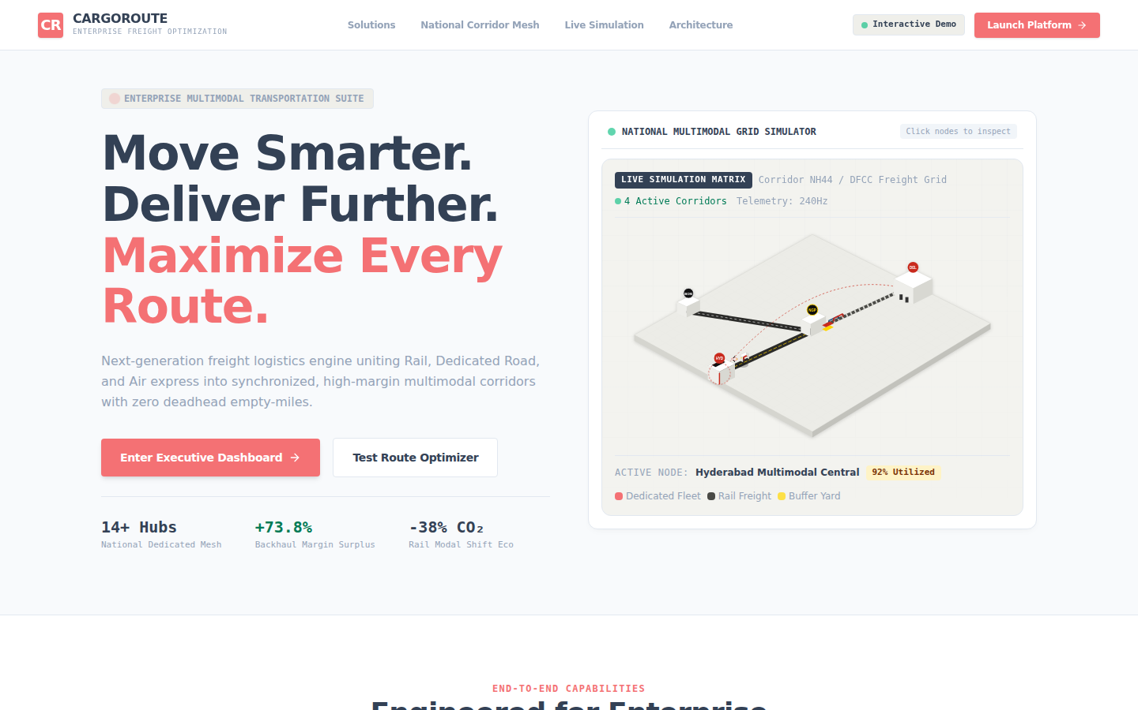
Figure 1: CargoRoute landing page
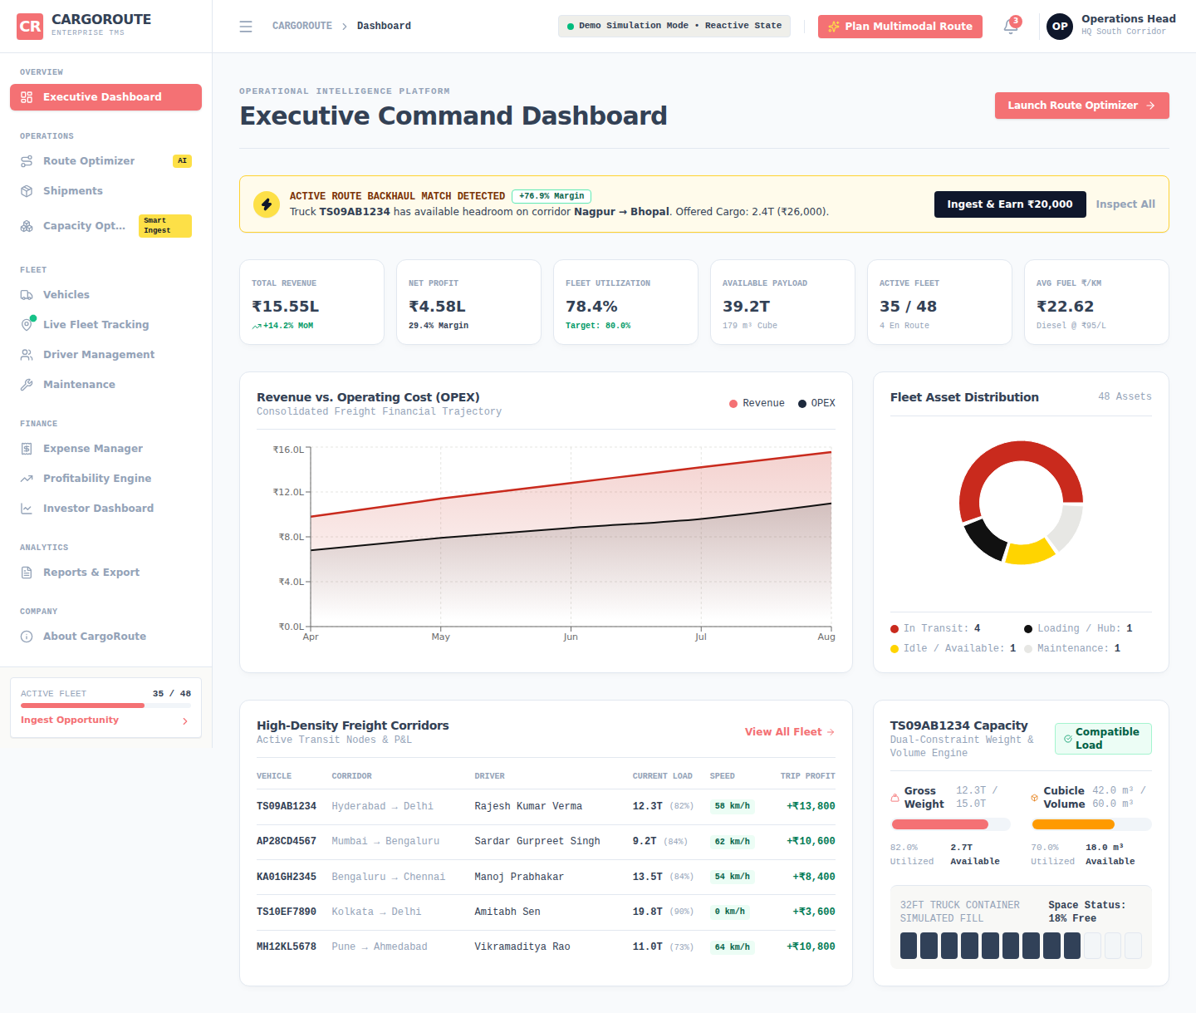
Figure 2: Executive Command Dashboard — KPIs, revenue/profit trend and fleet status

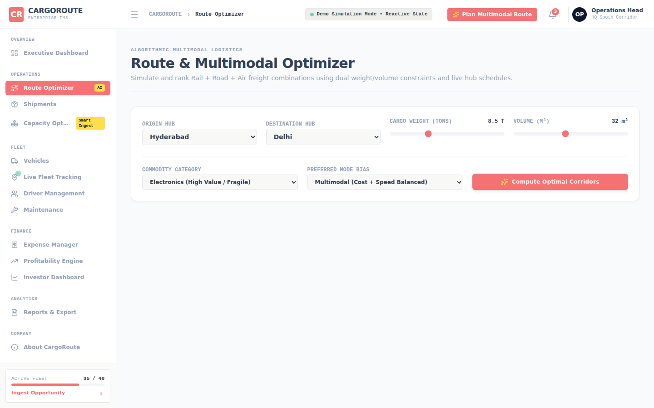
Figure 3: Route Optimizer — input form (Hyderabad → Delhi, 8.5 T, 32 m³)
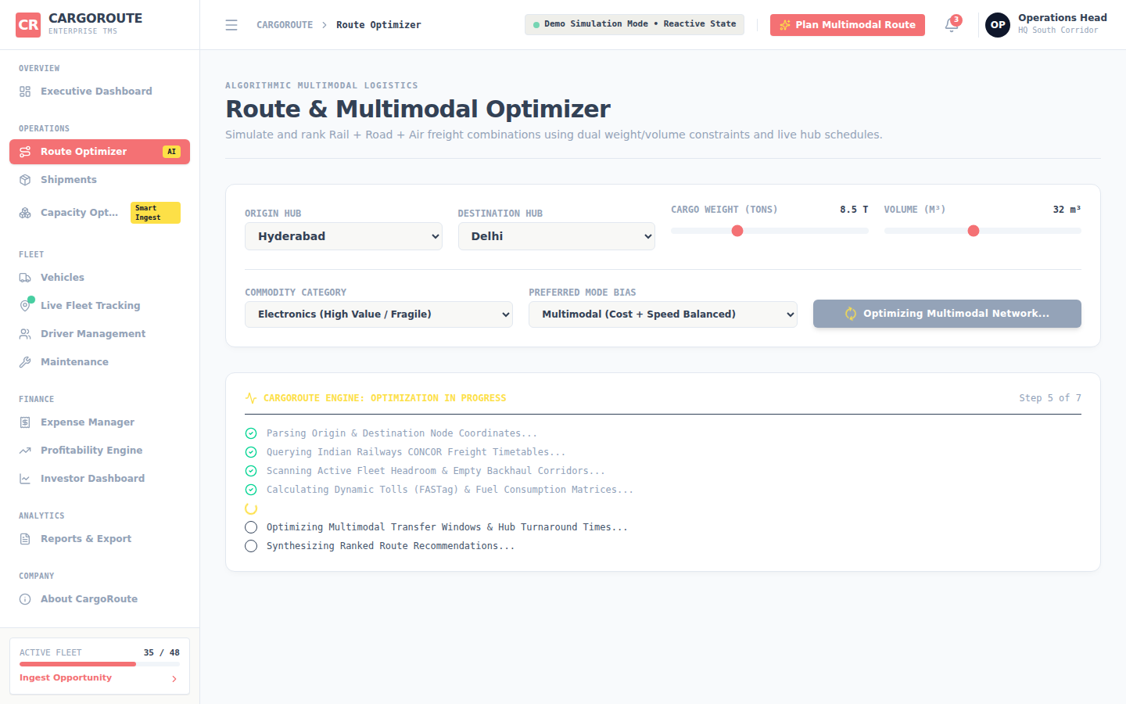
Figure 4: Optimization sequence running (step-by-step engine messages)

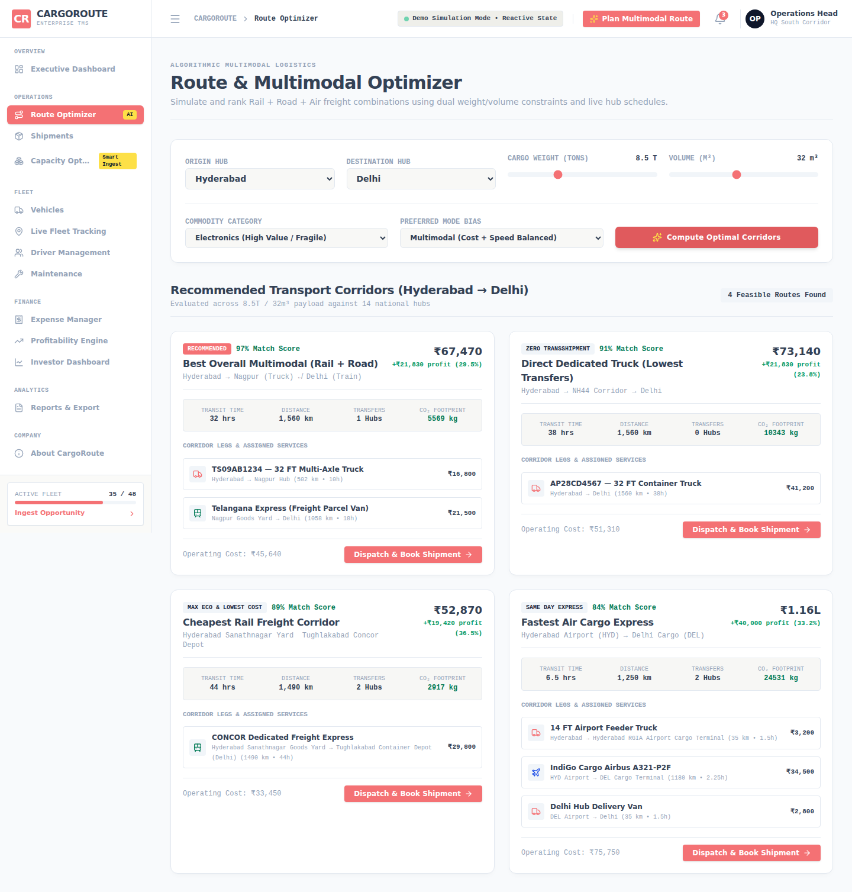
Figure 5: Four ranked corridors — Rail + Road (97 % match), Direct Truck, Rail, Air

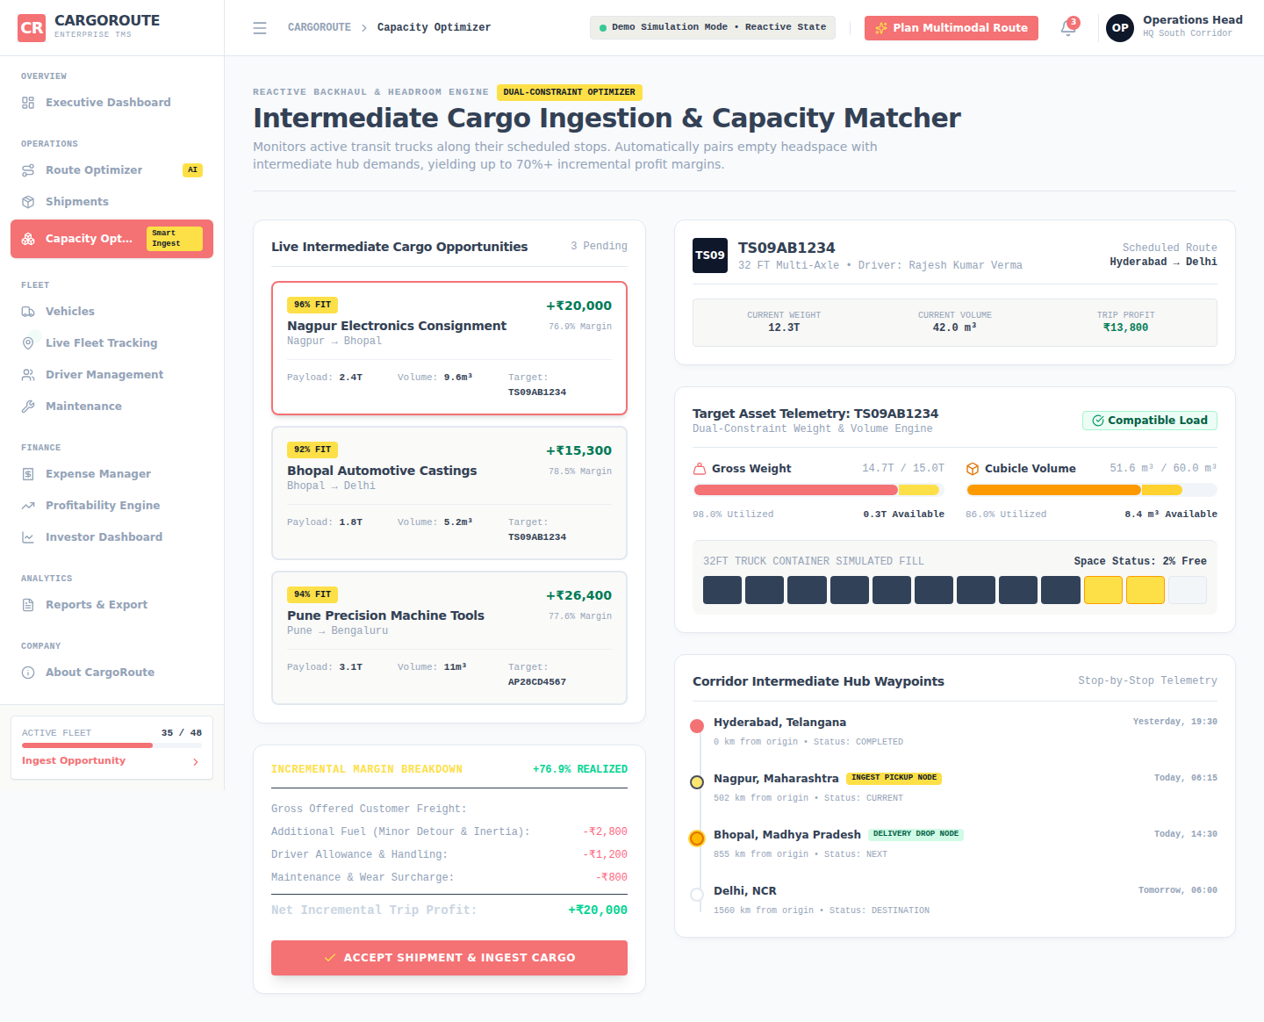
Figure 6: Capacity Optimizer — opportunity list, margin breakdown (+₹20,000, 76.9 %) and weight/volume telemetry

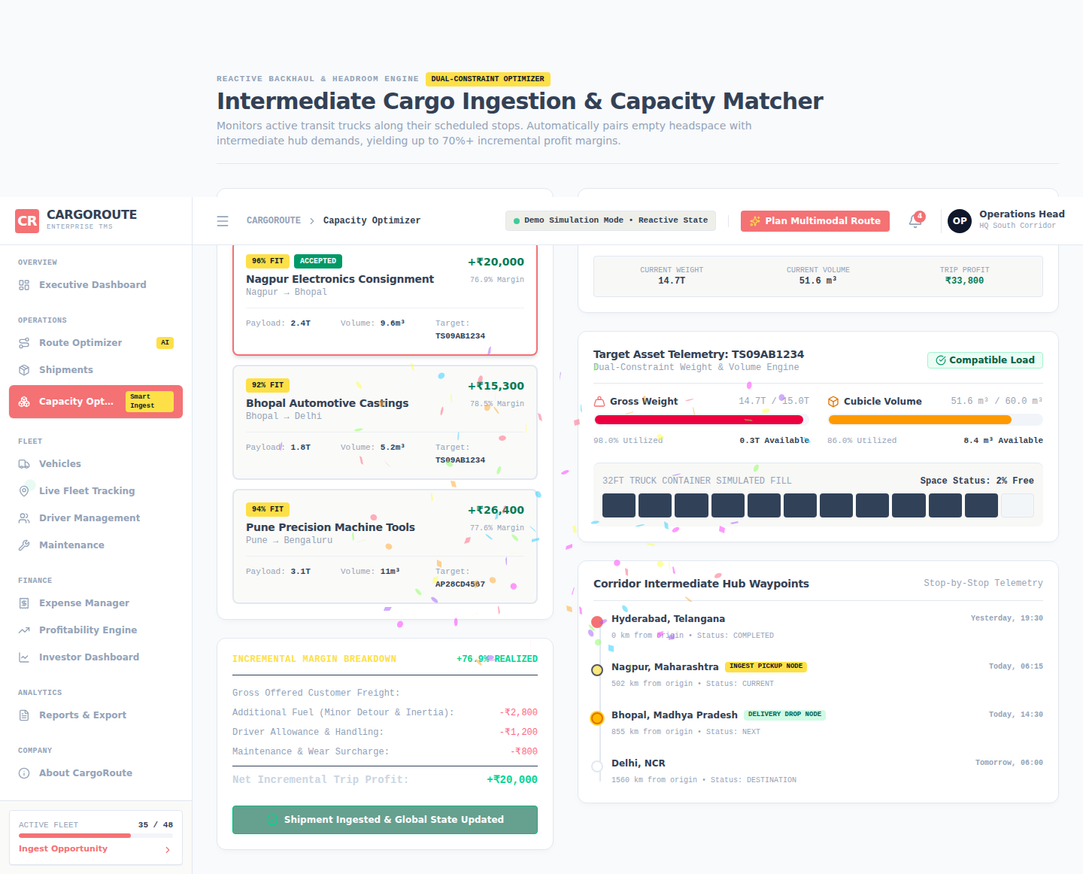
Figure 7: After “Accept Shipment & Ingest Cargo” — opportunity marked accepted, truck load updated
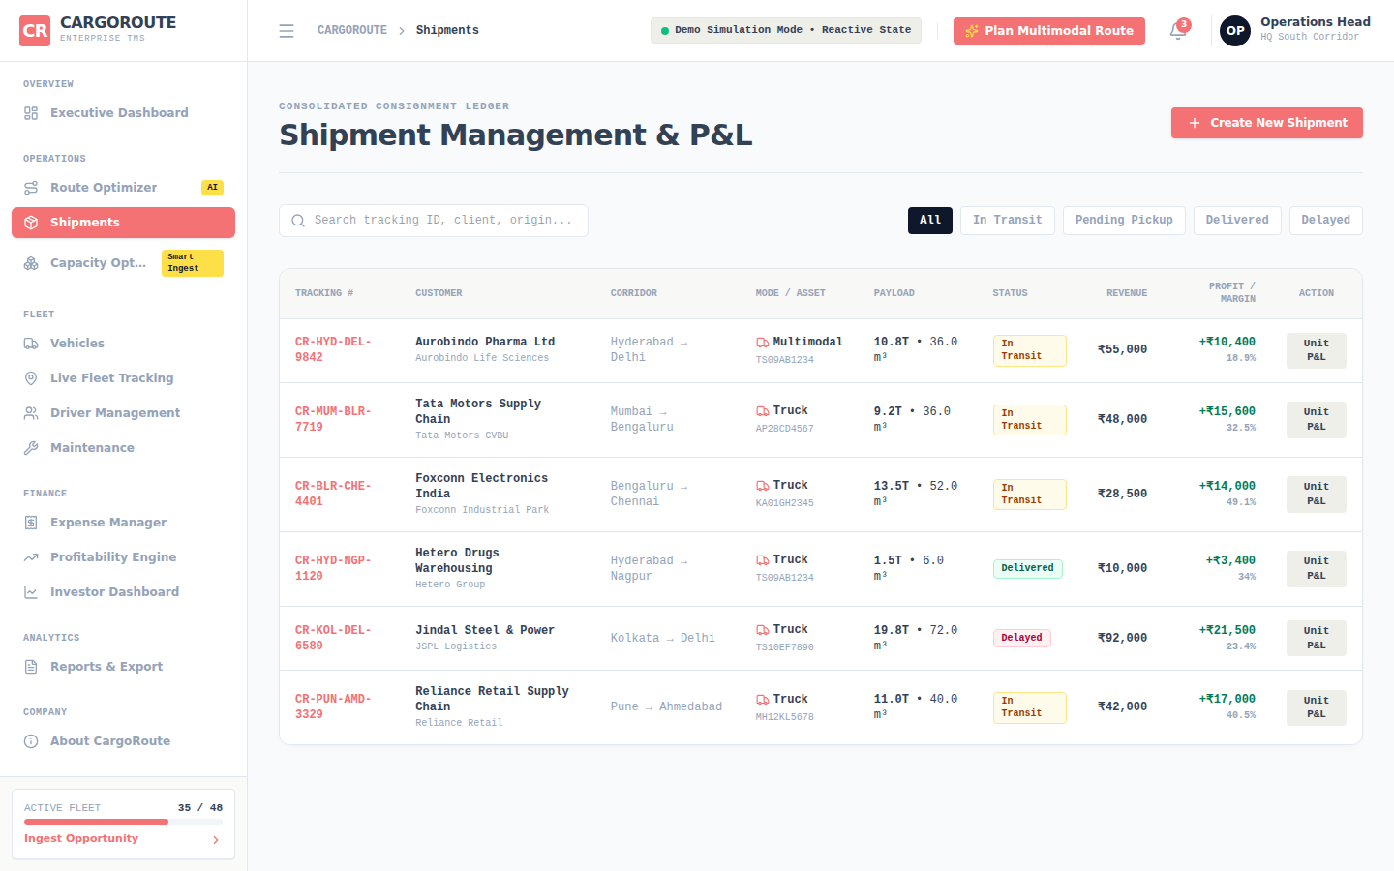
Figure 8: Shipments register with search and status filter

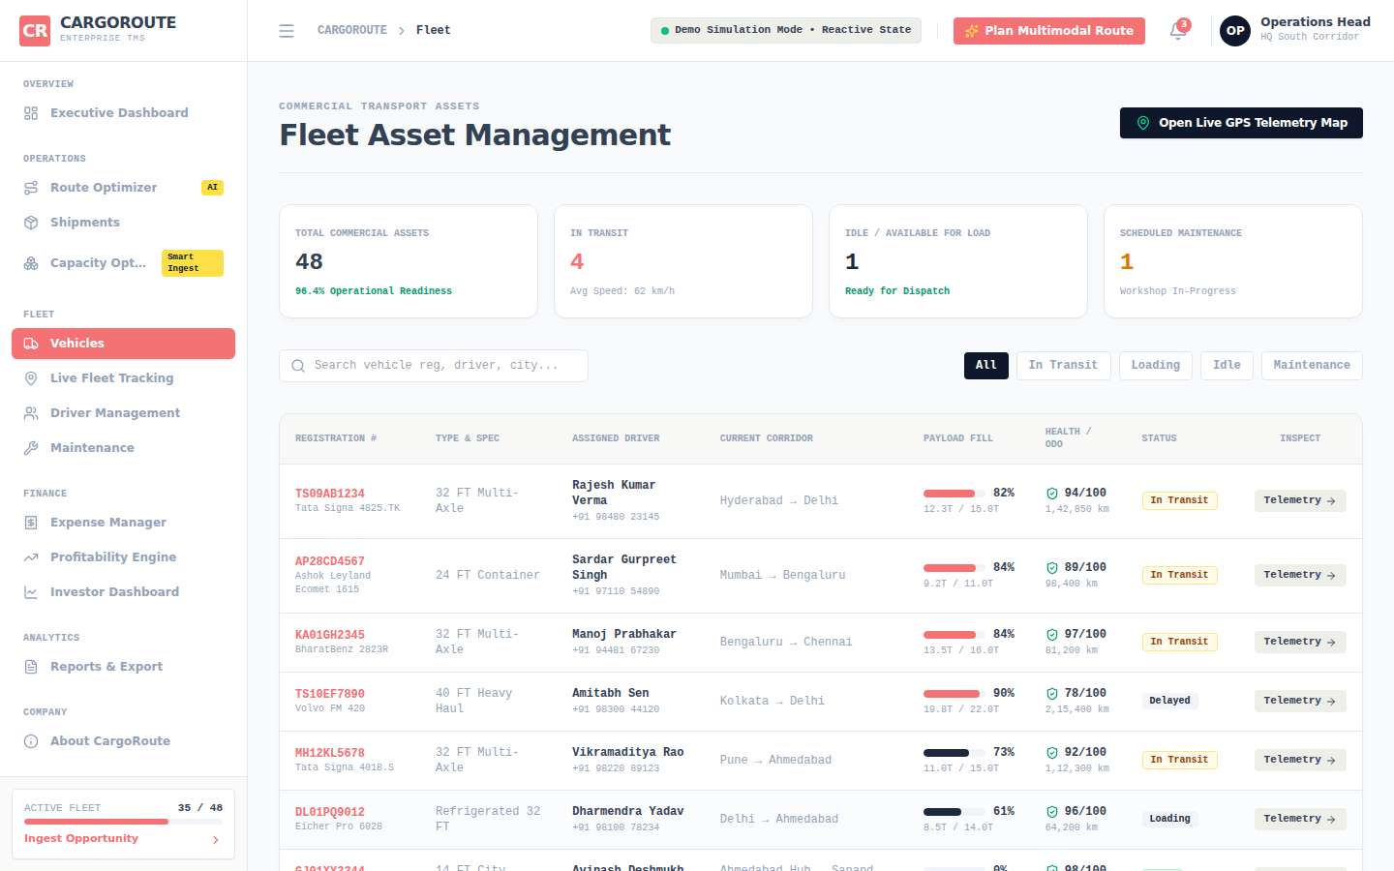
Figure 9: Fleet management page
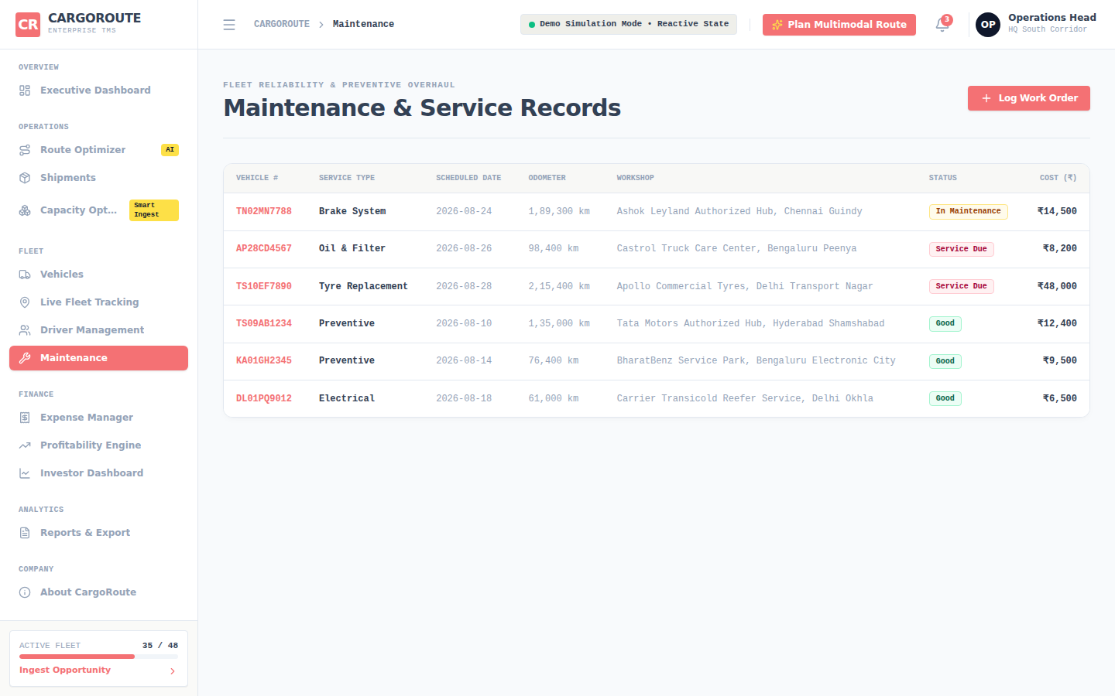
Figure 10: Maintenance and service records

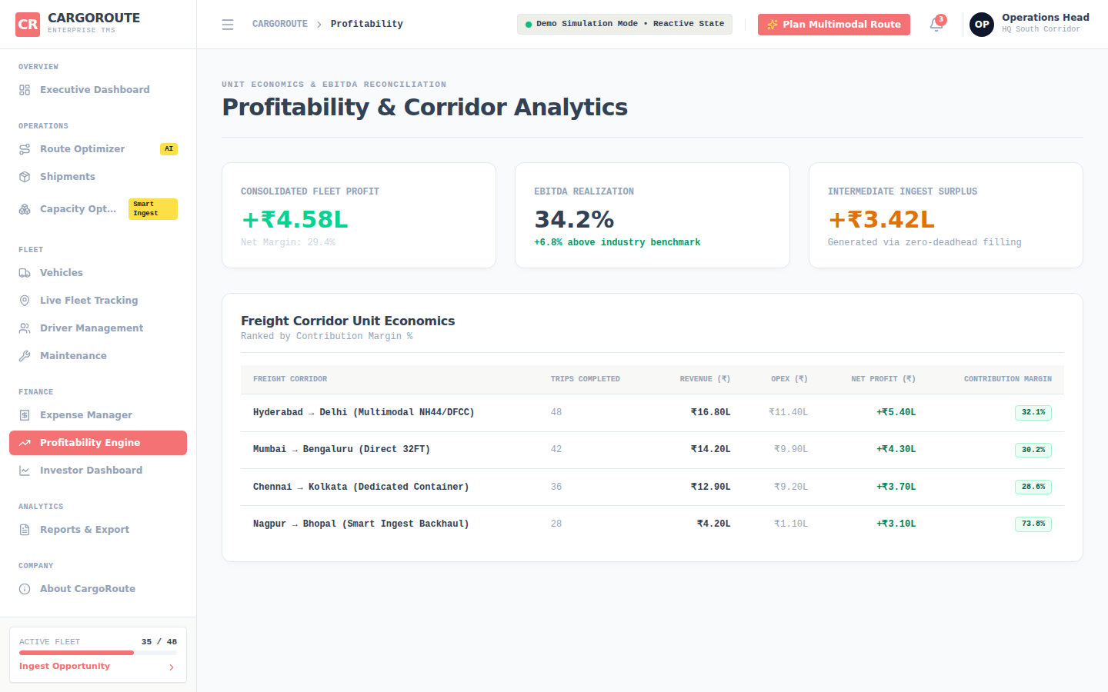
Figure 11: Profitability engine with corridor ranking and scenario controls
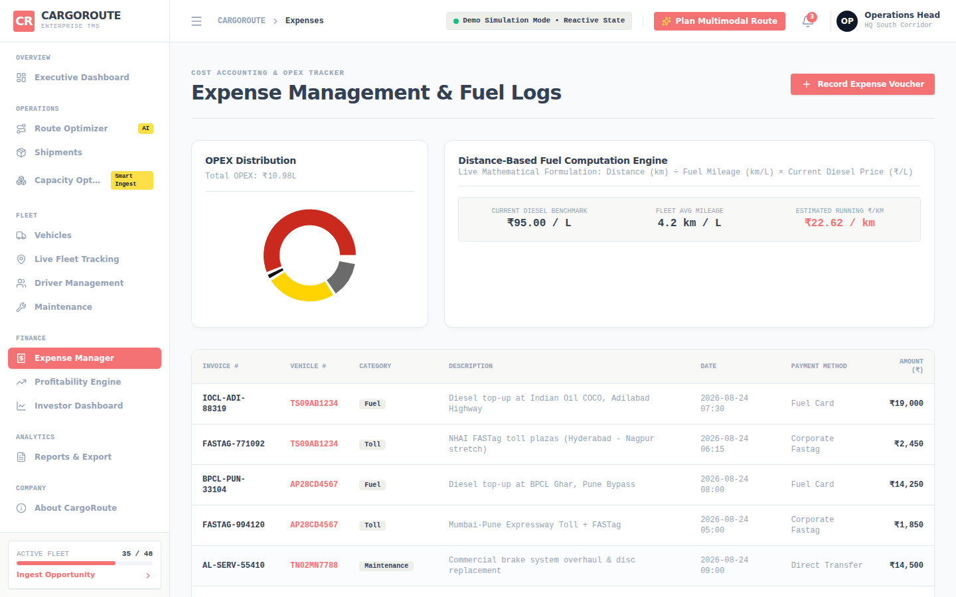
Figure 12: Expense manager
Summary of Results
Test | Input | Output
Route planning | Hyderabad → Delhi, 8.5 T, 32 m³ | 4 options; recommended Rail + Road: ₹45,640 cost, ₹67,470 price, ₹21,830 profit, 32 h, 5,569 kg CO₂
Cheapest option | same | Rail corridor: ₹33,450 cost, 44 h, 2,917 kg CO₂
Fastest option | same | Air express: 6.5 h, ₹75,750 cost
Capacity check | Truck TS09AB1234 + 2.4 T / 9.6 m³ | 14.7 T / 15.0 T and 51.6 m³ / 60.0 m³ → Compatible Load
Opportunity economics | Nagpur → Bhopal, ₹26,000 offered | Additional cost ₹6,000; net profit ₹20,000; margin 76.9 %

Conclusion and Limitations
CargoRoute shows how simple, well-structured algorithms — cost formulas, a dual-constraint feasibility test, linear scans and aggregations — can turn freight planning into a clear and fast decision process, and how filling spare truck capacity raises the margin of a trip from about 24–36 % to about 77 %.
Limitations of the present prototype: the route options are rule-based templates with fixed rates, durations and service names rather than a search over a real hub graph; the profit-margin percentage shown for each route is a preset value rather than profit ÷ price; accepting intermediate cargo clamps the truck load to its maximum instead of re-checking and rejecting an overload; and all data is simulated in the browser. Future work: model the 14 hubs as a weighted graph and use shortest-path or minimum-cost flow algorithms, connect real carrier and GPS data, and add a backend database.

